PIZZA SALES ANALYSIS

1. KPI’s
2. **Total Revenue:**

SELECT SUM(total_price) AS Total_Revenue FROM pizza_sales_data;

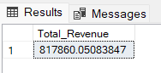

1. **Average Order Value:**

SELECT (SUM(total_price) / COUNT(DISTINCT order_id)) AS Avg_order_Value FROM pizza_sales_data

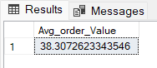

1. **Total Pizzas Sold:**

SELECT SUM(quantity) AS Total_pizza_sold FROM pizza_sales_data

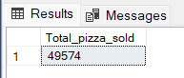

1. **Total Orders:**

SELECT COUNT(DISTINCT order_id) AS Total_Orders FROM pizza_sales_data

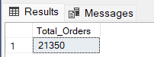

1. **Average Pizzas Per Order:**

SELECT CAST(CAST(SUM(quantity) AS DECIMAL(10,2)) /

CAST(COUNT(DISTINCT order_id) AS DECIMAL(10,2)) AS DECIMAL(10,2))

AS Avg_Pizzas_per_order

FROM pizza_sales_data

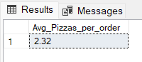

1. **Daily Trends for Orders**

SELECT DATENAME(DW, order_date) AS order_day, COUNT(DISTINCT order_id) AS total_orders

FROM pizza_sales_data

GROUP BY DATENAME(DW, order_date)

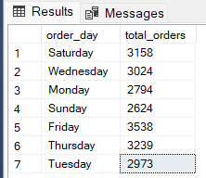

1. **Monthly Trends for Orders**

select DATENAME(MONTH, order_date) as Month_Name, COUNT(DISTINCT order_id) as Total_Orders

from pizza_sales_data

GROUP BY DATENAME(MONTH, order_date)

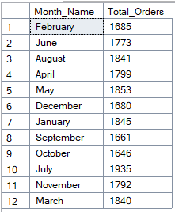

1. **% of Sales by Pizza Category**

SELECT pizza_category, CAST(SUM(total_price) AS DECIMAL(10,2)) as total_revenue,

CAST(SUM(total_price) * 100 / (SELECT SUM(total_price) from pizza_sales) AS DECIMAL(10,2)) AS PCT

FROM pizza_sales_data

GROUP BY pizza_category

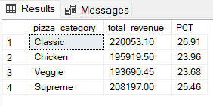

1. **% of Sales by Pizza Size**

SELECT pizza_size, CAST(SUM(total_price) AS DECIMAL(10,2)) as total_revenue,

CAST(SUM(total_price) * 100 / (SELECT SUM(total_price) from pizza_sales) AS DECIMAL(10,2)) AS PCT

FROM pizza_sales_data

GROUP BY pizza_size

ORDER BY pizza_size

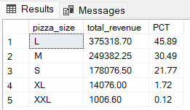

1. **Total Pizza Sold by Pizza Category**

SELECT pizza_category, SUM(quantity) as Total_Quantity_Sold

FROM pizza_sales_data

WHERE MONTH(order_date) = 2

GROUP BY pizza_category

ORDER BY Total_Quantity_Sold DESC

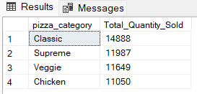

1. **Top 5 Pizzas by Revenue**

SELECT Top 5 pizza_name, SUM(total_price) AS Total_Revenue

FROM pizza_sales_data

GROUP BY pizza_name

ORDER BY Total_Revenue DESC

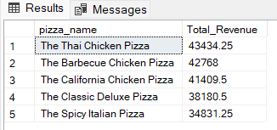

1. **Bottom 5 Pizzas by Revenue**

SELECT Top 5 pizza_name, SUM(total_price) AS Total_Revenue

FROM pizza_sales_data

GROUP BY pizza_name

ORDER BY Total_Revenue ASC

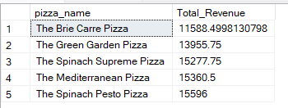

1. **Top 5 Pizzas by Quantity**

SELECT Top 5 pizza_name, SUM(quantity) AS Total_Pizza_Sold

FROM pizza_sales_data

GROUP BY pizza_name

ORDER BY Total_Pizza_Sold DESC

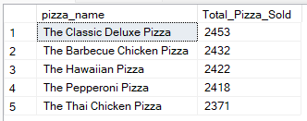

1. **Bottom 5 Pizzas by Quantity**

SELECT TOP 5 pizza_name, SUM(quantity) AS Total_Pizza_Sold

FROM pizza_sales_data

GROUP BY pizza_name

ORDER BY Total_Pizza_Sold ASC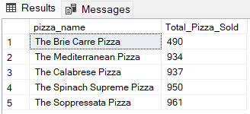

1. **Top 5 Pizzas by Total Orders**

SELECT Top 5 pizza_name, COUNT(DISTINCT order_id) AS Total_Orders

FROM pizza_sales_data

GROUP BY pizza_name

ORDER BY Total_Orders DESC

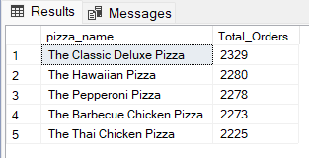

1. **Bottom 5 Pizzas by Total Orders**

SELECT Top 5 pizza_name, COUNT(DISTINCT order_id) AS Total_Orders

FROM pizza_sales_data

GROUP BY pizza_name

ORDER BY Total_Orders ASC

